Exemple of algorithm: integer multiplication (primary school algorithm)

Complexity: number of basic operations as being a function of the size of data inputed

IN the integer multiplication, the complexity is function of the length of the numbers multiplied, so constant * n²

Loop invariant what holds true throughout a loop (usually defined right before it and staying constant throughout all the iterations of the loop)

Karatsuba multiplication

Divide and Conquer divide into smaller subproblems, make recursive calls and merge back

Counting inversion counting the number of cases in an array of numbers where two values are inverted (aka the one with the smaller index is bigger than his right-hand neighbour). For example a sorted array has zero inversions.
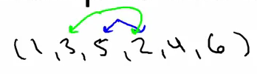
Useful for dating sites: let's say we compare two people's favorite movies. If star wars is your favorite movie, and your friend's, we put a one in the first index of the array, if it is only his fifth favorite movie, we put a five and so on. The more inversions there is, the less compatible these two people are.

Strassen's Subcubic Matrix Multiplication algorithm Normally, the running time of matrix multiplication is theta of n³

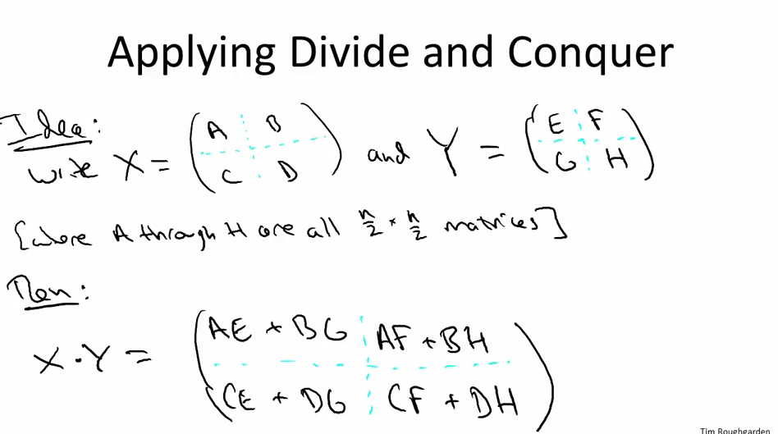
Algorithm for closest pair Used in graphic computing.
First step:
divide the points by a line in the middle, creating two equal sets of points and use the recursion on them and finding the min distance between two points in each of those areas. Then , take the min of these two mins and create an aera around the dividing line of width W = 2*min distance and use a new recursion on the points inside that zone (place each point in a square/rectangle which size is relative to d and conclude how many points are in its neighborhood.
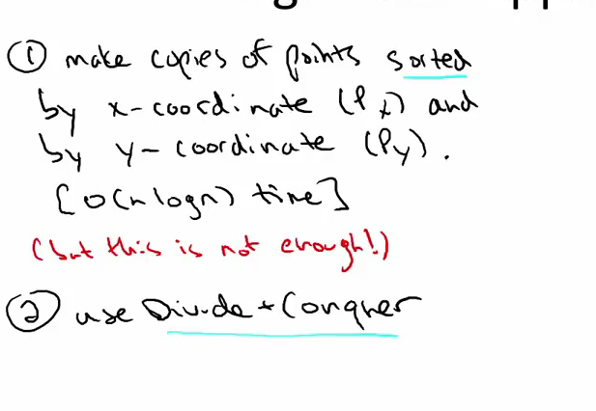
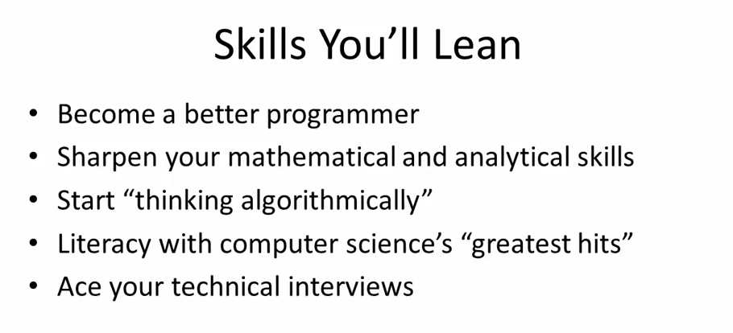

*---------------*

The following problems are for those of you looking to challenge yourself beyond the required problem sets and programming questions. Most of these have been given in Stanford's CS161 course, Design and Analysis of Algorithms, at some point. They are completely optional and will not be graded. While they vary in level, many are pretty challenging, and we strongly encourage you to discuss ideas and approaches with your fellow students on the "Theory Problems" discussion form.
- [Posted October 5th] You are given as input an unsorted array of n distinct numbers, where n is a power of 2. Give an algorithm that identifies the second-largest number in the array, and that uses at most n+log2n−2 comparisons.
- [Posted October 5th] You are a given a unimodal array of n distinct elements, meaning that its entries are in increasing order up until its maximum element, after which its elements are in decreasing order. Give an algorithm to compute the maximum element that runs in O(log n) time.
- [Posted October 5th] You are given a sorted (from smallest to largest) array A of n distinct integers which can be positive, negative, or zero. You want to decide whether or not there is an index i such that A[i] = i. Design the fastest algorithm that you can for solving this problem.
- [Posted October 5th] Give the best upper bound that you can on the solution to the following recurrence: T(1)=1 and T(n)≤T([n√])+1 for n>1. (Here [x] denotes the "floor" function, which rounds down to the nearest integer.)
- [Posted October 5th] You are given an n by n grid of distinct numbers. A number is a local minimum if it is smaller than all of its neighbors. (A neighbor of a number is one immediately above, below, to the left, or the right. Most numbers have four neighbors; numbers on the side have three; the four corners have two.) Use the divide-and-conquer algorithm design paradigm to compute a local minimum with only O(n) comparisons between pairs of numbers. (Note: since there are n2 numbers in the input, you cannot afford to look at all of them. Hint: Think about what types of recurrences would give you the desired upper bound.)
Remember that some operations you do in your program won't affect the performance because they have a similar running time so don't be afraid to include code at the beginning that might seem useless at first.

